# Sequence: Text parsing with the selected delimiters

| **Subject** | **Subject Action** | **Parameters** | **Object Acted Upon** |
| --- | --- | --- | --- |
| User | Provides text to parse | Text, chosen delimiter | Parser |
| Parser | Parse | Text, delimiter | Text Data |
| Parser | Create parsed outputs | Card front/back data from text | Parser |
| Parser | Create flashcards | Parsed front/back data | Card Collection |
| Parser | Display | Confirmation message for completion | User |

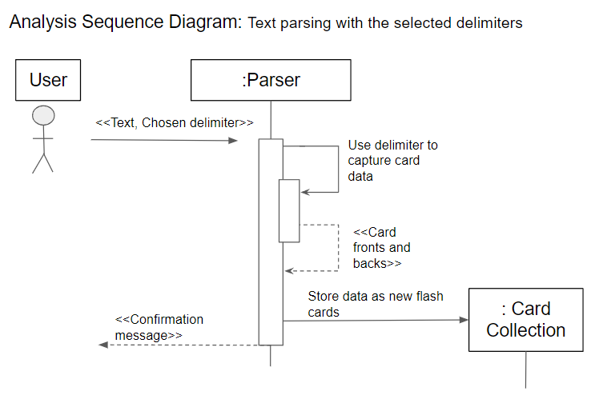

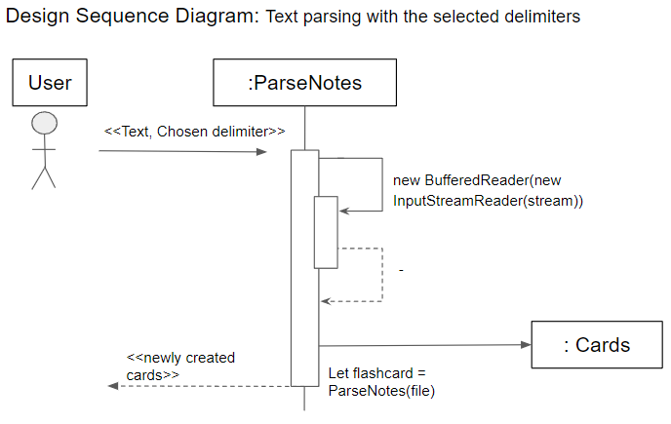

# Sequence: Adding cards to decks

|  | **Subject** | **Subject Action** | **Parameters** | **Object Acted Upon** |
| --- | --- | --- | --- | --- |
|  | User | Make selection | Cards, decks | Controller |
|  | Controller | Pass inputs | Cards. decks | Card Collection |
| Loop: For each selected card and deck | Card Collection | Pass cards | Selected cards | Each Selected Deck |
| Each Selected Deck | Identify duplicate cards | Deck’s included cards, selected card list | Each Selected Deck |
| Each Selected Deck | Add card references | Selected cards, duplicate cards to ignore | Each Selected Deck |
| Each Selected Card | Identify duplicate decks | Decks card is in, selected decks | Each Selected Card |
| Each Selected Card | Add deck references | Selected decks, duplicate decks to ignore | Each Selected Card |

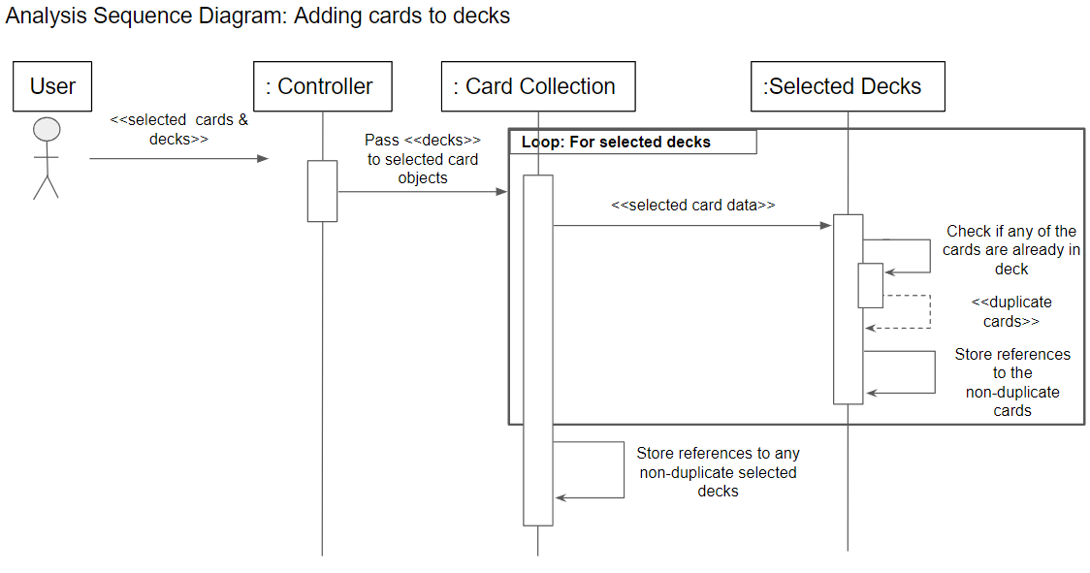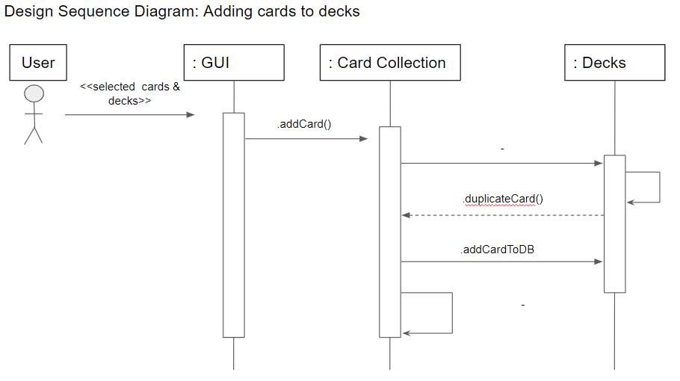

# Sequence: Export Flashcards to Text File

| **Subject** | **Subject Action** | **Parameters** | **Object Acted Upon** |
| --- | --- | --- | --- |
| User | Make selection | Cards, export location | GUI |
| Controller | Pass information | Cards, File path | Operating System |
| Operating System | Create text file | File location | Text File |
| Operating System | Write text data | Card information | Text File |
| Operating System | Report success | Export location | Controller |
| Controller | Confirm export by reading new text file | Export location | Operating System |
| Controller | Report success | Export location | GUI |
| GUI | Display | Success message, file location | User |

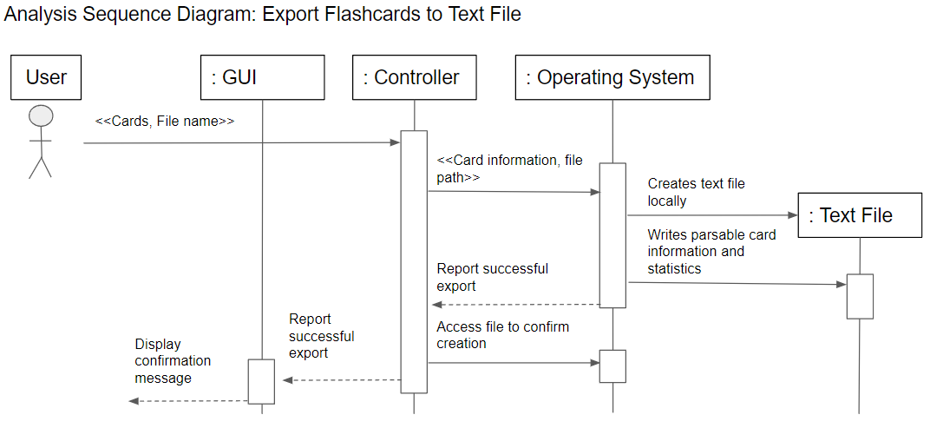

# Sequence: Import Flashcards from Text File

| Subject | Subject Action | Parameters | Object Acted Upon |
| --- | --- | --- | --- |
| User | Provide import file | File path | Controller |
| Controller | Pass file information for reading | File path | Operating System |
| Operating System | Open file | File path | Text File |
| Controller | Parse file | Import delimiter | Text File |
| Text File | Return | Parsed card data | Controller |
| Controller | Add cards to collection | Parsed card data | Card Collection |
| Controller | Report Success | File location | GUI |
| GUI | Display success message | File location | User |

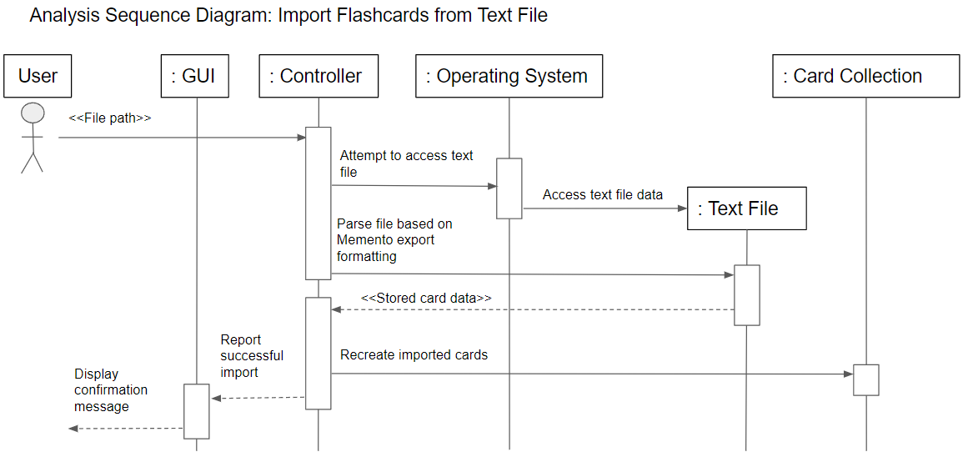

# Sequence: Delete Cards

|  | **Subject** | **Subject Action** | **Parameters** | **Object Acted Upon** |
| --- | --- | --- | --- | --- |
|  | User | Make selection of cards | Selected cards | Controller |
| Loop 1: For each selected card | Controller | Access referenced decks | Card’s deck reference list | Each Selected Card |
| Loop 2: For all decks referenced by current card in loop 1 | Each Selected Card | Remove from deck | Card data | Each Selected Deck |
| End loop 2 | Each Selected Card | Remove from scheduler | Card data | Each Selected Deck |
| End loop 1 | Controller | Delete card | None | Each Selected Card |

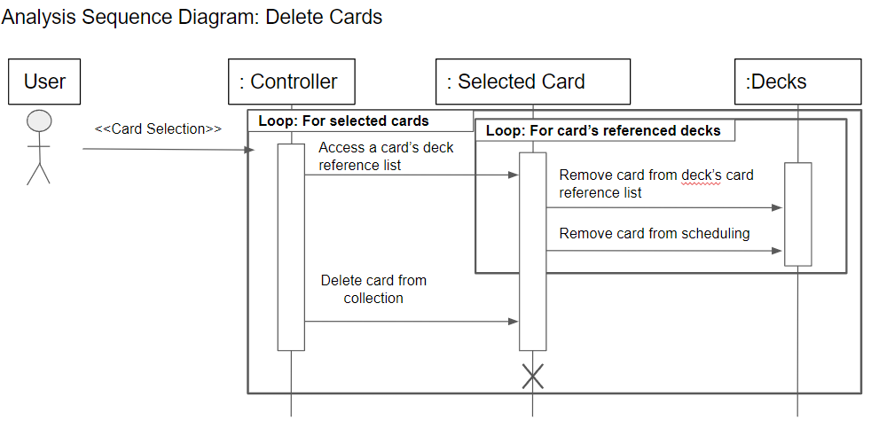

# Sequence: Delete Deck

| **Subject** | **Subject Action** | **Parameters** | **Object Acted Upon** |
| --- | --- | --- | --- |
| User | Selection of deck | Deck | Controller |
| Controller | Access deck’s card reference list | Deck | Decks |
| Decks | Unlist deck from referenced cards | Deck’s referenced card list | Card Collection |
| Controller | Unlist deck | Deck, Deck collection | Decks |
| Controller | Delete deck | None | Decks |

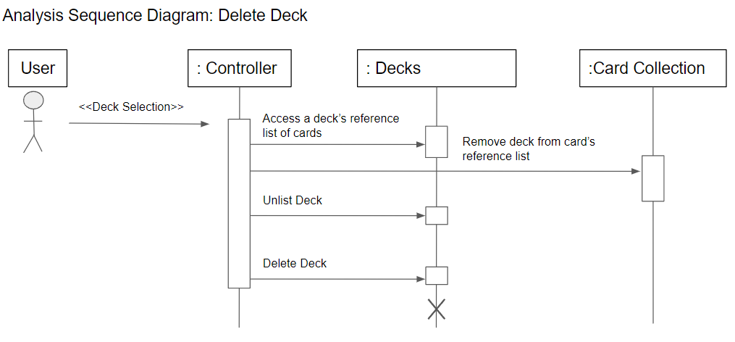

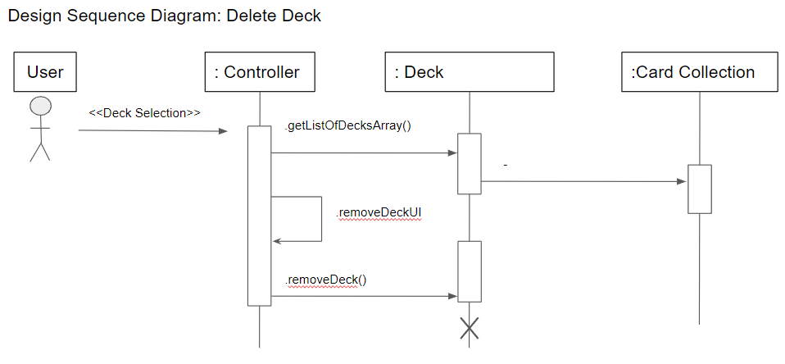

# Sequence: Study a Deck

|  | **Subject** | **Subject Action** | **Parameters** | **Object Acted Upon** |
| --- | --- | --- | --- | --- |
|  | User | Select deck | Deck | Deck |
|  | Deck | Signal scheduler | Deck | Scheduler |
| Loop: Until user exits study menu/loop | Scheduler | Get card data | Deck schedule, next card | Card Collection |
| Card Collection | Pass card data | Card front and back | GUI |
| GUI | Display | Card front | User |
| User | Make guess and flip | None | GUI |
| GUI | Display | Card back | User |
| User | Report result | Correct/Incorrect | GUI |
| GUI | Update scheduler | Card, reported result | Scheduler |

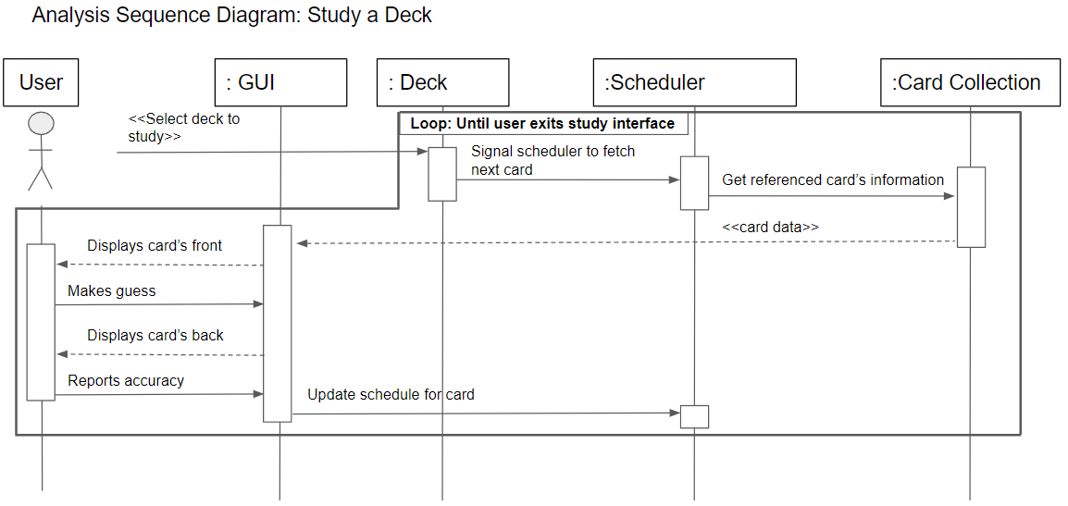

# Sequence: Quiz a Deck

|  | **Subject** | **Subject Action** | **Parameters** | **Object Acted Upon** |
| --- | --- | --- | --- | --- |
|  | User | Select deck | Deck | Deck |
|  | Deck | Signal scheduler | Deck | Scheduler |
| Loop: once per card in deck | Scheduler | Get card data | Deck schedule, next card | Card Collection |
| Card Collection | Pass card data | Card front and back | GUI |
| GUI | Display | Card front | User |
| User | Make guess and flip | None | GUI |
| GUI | Display | Card back | User |
| User | Report result | Correct/Incorrect | GUI |
| GUI | Update score | Reported result | Scheduler |
|  | Scheduler | Return | Overall quiz accuracy | GUI |
|  | GUI | Display | Quiz accuracy | User |

